Figure (a) .

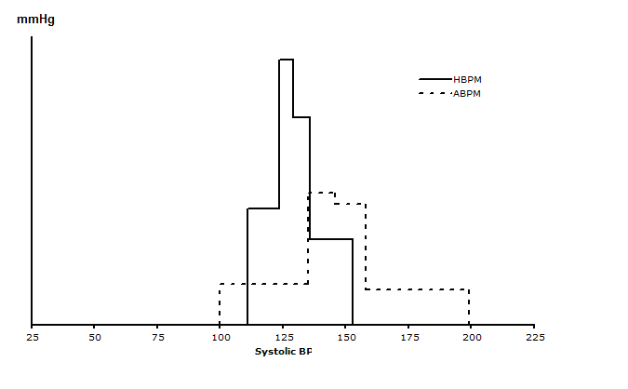
Figure (b)
Frequency distributions of ABPM and HBPM

